Chapter 10, Problem 29.

Using Fig. 10.77, design a problem to help other students better understand mesh analysis.
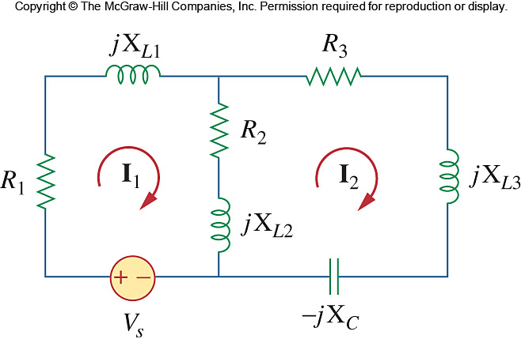

Figure 10.77
For Prob. 10.29

